A cover letter is an important way to showcase how your unique combination of skills and experience meet the key requirements of the job description. It is your chance to show a clear link between your knowledge, experience and abilities and the needs of the employer. The wording of your cover letter can express your personality in a way that your resume cannot. The tone of your letter gives the employer an important insight into your personality and the kind of traits that could add value to their team. It allows you to explain in your own words why you are the best person for the job.

COVER LETTER FORMAT

- Date & Contact Information. Make sure you include a way for them to get in contact with you. Provide a phone number, address, and an email address. Make sure this information is left-hand aligned. In a separate line, include the date of the day you are sending the letter. Helpful tip: Make sure your email address is appropriate and matches for the job you want.

- Salutation/Greeting. Start by introducing your letter with a standard greeting like “Dear,” or “Hello.” Follow the greeting with either the hiring manager’s name or if a name isn’t listed feel free to say hiring manager, to whom it may concern, or a human resource manager.

- Opening Paragraph. Write an introductory paragraph that includes the position you're applying for. You should start with a statement about your enthusiasm for the role and company.

- Middle Paragraph. Your second paragraph should be a brief overview of your background as is relevant to the position. Here, you should include key achievements, skills and specialties that make you particularly suited to perform well in the position. Focus on key achievements or skills that are relevant to the position. Instead of repeating details from your resume, expand on specific stories or anecdotes that display your talents for the role. Helpful Hint: Pay close attention to keywords listed in the job description and include those that you identify within the body of your cover letter. You should only include information about your most recent experiences.

- Closing Paragraph. Your last paragraph should recap the reasons you are applying for the role and why you would be a great fit for the job. Keep the closing conclusion brief and explain that you look forward to hearing from the employer with next steps.

- End It. Finally, sign your name after a closing line like “all the best,” or “sincerely.”

A resume is an important tool for your job search as it offers a page where you can display your top skills and qualities. However, a resume also serves much more than that. They help employers make hiring decisions and help you get your first interview. That’s why it matters how you structure your resume and what information you decide to include.

Types of Resumes

Chronological Resumes: Most resumes are ordered this way. It’s traditional to put your most recent job at the top of the experience section. You want to display seven to ten years of relevant work experience, in addition to other accolades.

Custom Resumes: This type of resume prioritizes relevant education and experiences over order. Might be used by someone who is changing careers or new to the workforce or someone with gaps in employment. It can also be used for people with a lot of exceptional experience in a specialized industry.

Style: Use a common, easy to read font in a readable size, typically 10 - 12 point font. Set all margins between .5 to 1 inch. Use bold, underlining, and italics purposefully and consistently to separate sections and highlight content.

Format: Limit to one page UNLESS more are typical in your field and you have relevant content for a second page. List education, experiences, etc. in reverse chronological order, with the most recent first. Develop an unformatted version of your resume with no bold, italics, or other designs to copy into online application systems.

AVOID: Paragraph descriptions of experience. Pronouns referring to yourself, i.e. I, my, our, and we. Inconsistencies in layout or formatting. Photographs, clip-art, and boards. Oversharing, especially personal information, i.e. hobbies and marital status. Abbreviations not widely known. Rounding your GPA up. Listing unsubstantiated soft skills. Templates which reduce control or may not be readable by online application systems. Tables and grids which may not transfer across platforms or be readable by online application systems. Distracting colors or designs, unless expected in the field.

Transferable skills: Most students won’t have a lot of direct experience in the fields they wish to work in; therefore, employers are interested in the skill sets that can be transferred from one industry or field to another. These are called transferable skills because they are associated with professional success in any industry. Examples include: Problem-Solving, Ability to work on a team, strong work ethic, analytical/quantitative skills, communication skills (written/verbal), leadership, initiative, detail-oriented, technical skills, flexibility/adaptability, interpersonal skills, computer skills, organizational ability, strategic planning skills, friendly/outgoing personality, entrepreneurial skills, tactfulness, and creativity.

Bullet Statements: Bullet statements describe your activities, skills, and results. They may be used to describe jobs, internships, involvement, research, volunteer positions and academic/independent projects. The Basics. Start your bullet statement with an ACTION VERB which clearly describes the activity. Include numbers to give context to an activity and/or to show results. Answer the questions, “what?”, “how?”, and “why?” of the activity you are listing.

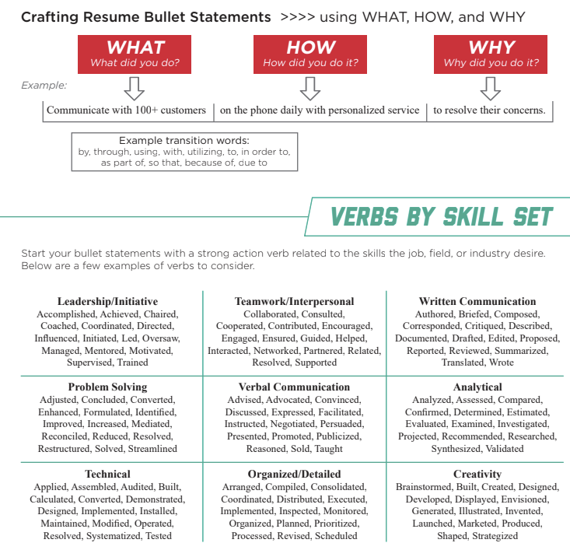

RESUME ORGANIZER
Keep Track of Where You’ve Sent Your Resume

Company #1:
Address:
Contact Name:
Title:
Email/Phone:
Date Resume Sent:
Date of Follow Up:
Notes:

Company #2:
Address:
Contact Name:
Title:
Email/Phone:
Date Resume Sent:
Date of Follow Up:
Notes:

Company #3:
Address:
Contact Name:
Title:
Email/Phone:
Date Resume Sent:
Date of Follow Up:
Notes:

Company #4:
Address:
Contact Name:
Title:
Email/Phone:
Date Resume Sent:
Date of Follow Up:
Notes:

